Phase 5 – Salesforce Expense Report Process Enhancements

Name: Shaik Javeed Ahammad

1.Introduction Up to Phase 4, the Salesforce Expense Report system successfully automated multi-level approvals and introduced notifications, validation, and dashboards. However, modern organizations expect more than just structured approvals—they demand real-time communication, mobile accessibility, and intelligent monitoring of financial activities.

Phase 5 focuses on transforming the existing approval process into a smarter, more collaborative, and proactive system. By integrating with platforms like Slack or Microsoft Teams, employees and managers will no longer be limited to emails for communication. Instead, they will receive instant notifications and be able to take action directly within the messaging platform.

In addition, approvals are extended to the Salesforce Mobile App, giving managers the ability to review receipts and approve or reject expense reports while on the move. Escalation rules are introduced to ensure that no report is left pending indefinitely, while artificial intelligence (AI) capabilities are leveraged to detect anomalies or fraudulent claims. Predictive dashboards are also implemented to provide executives with foresight into upcoming expense trends, helping them make proactive financial decisions.

2. Objectives

The main goals of Phase 5 are as follows:

• Provide seamless integration with collaboration tools so that employees and managers can

interact with the system in real-time without switching between platforms.

• Empower managers with mobile-first approval workflows, allowing them to process

approvals quickly, even outside of office environments.

• Introduce escalation rules that automatically reassign pending approvals to higher authorities if they remain unattended for too long.

• Use AI and machine learning to analyze spending patterns and detect anomalies that could indicate fraud, errors, or policy violations.

• Extend the reporting capability from being purely descriptive (showing what happened) to being predictive (forecasting what might happen).

3. Scope

This phase covers the enhancement of the approval process by:

1. Connecting Salesforce with collaboration platforms such as Slack or Microsoft Teams.

2. Configuring the Salesforce Mobile App to support expense approvals through quick actions and push notifications.

3. Defining escalation paths to ensure timely approval of expense reports.

4. Incorporating Einstein Discovery or external machine learning services to detect unusual expense claims.

5. Expanding dashboards to display predictive analytics and anomaly scores for more informed decision-making.

4. Implementation Steps

Step 1 – Integration with Collaboration Tools Salesforce provides connectors and APIs to integrate with popular messaging tools like Slack and Microsoft Teams. When this integration is set up, the workflow changes significantly:

• As soon as an employee submits an expense report, a Slack or Teams message is sent confirming that the submission has been logged.

• The assigned approver immediately receives a notification in Slack or Teams that contains the key details of the expense report, such as the employee name, the amount, and the receipt (if attached).

• Instead of logging into Salesforce, the approver can simply click an Approve or Reject button directly in the message. This drastically reduces delays because approvals can now be completed from within the tool that employees and managers are already using throughout the day.

Step 2 – Mobile Approvals

Modern organizations cannot rely solely on desktop workflows. Managers and directors often travel or work remotely, and waiting for them to return to a laptop can delay critical f inancial operations. To resolve this, the Salesforce Mobile App is configured with Quick Actions for approvals. With these actions enabled:

•Approvers can view all details of an expense report on their phone.

• They can tap Approve or Reject without opening the full Salesforce desktop site.

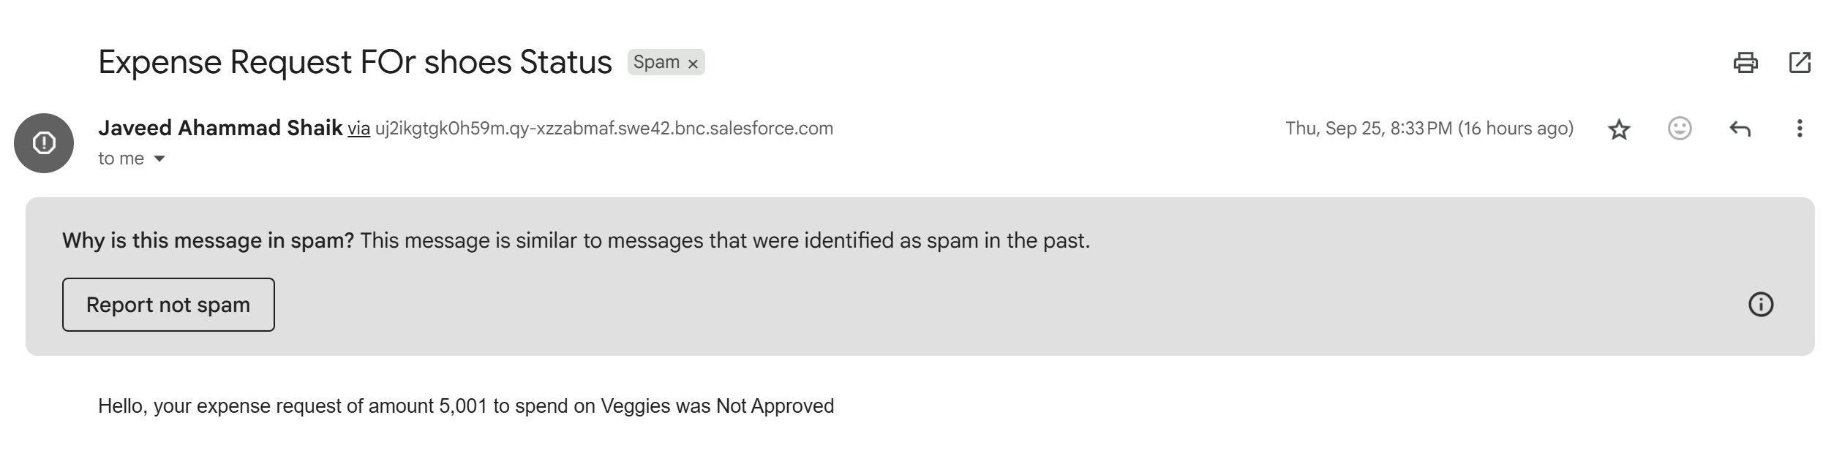



• Push notifications are enabled so that managers are instantly alerted whenever a new approval is pending. This feature makes the approval system location-independent and ensures that no expense is left waiting simply because an approver is away from their desk.

Step 3 – Escalation Rules One major risk in approval workflows is that a request can get stuck if the assigned approver forgets or delays action. To address this, Salesforce escalation rules and time-dependent workflows are introduced.

For example:

• If a manager does not act on an expense report within 48 hours, the request is automatically reassigned to the Director.

• If the Director does not act within 72 hours, it is escalated further to the CFO or Finance Head. This escalation path ensures accountability and prevents bottlenecks. The employee is also notified when escalation happens, which provides transparency and reassures them that their request is not being ignored.

Step 4 – AI/ML Anomaly Detection Fraud detection and anomaly detection are becoming essential in financial systems. By integrating Salesforce Einstein Discovery or a connected machine learning model, the system can automatically evaluate expense data to flag unusual reports. Some examples of anomalies that can be detected include:

• Employees submitting expenses that are consistently just below the approval threshold (e.g., always at 4,999 when the threshold is 5,000).

• Duplicate claims where the same receipt is uploaded multiple times.

• Abnormally high spending frequency by certain employees compared to their peers. When flagged, these reports are routed to a special manual review queue so that the f inance team can investigate further. This adds a layer of intelligence to the system, ensuring that it not only processes approvals but also guards against misuse.

Step 5 – Predictive Dashboards Dashboards are extended beyond simple reporting. With Einstein Analytics, predictive features are added:

• Predicted Expense Trends: Forecasts how much expense is expected in the next quarter, based on historical data.

• Anomaly Score Dashboards: Assigns a probability score to each report, indicating how likely it is to be fraudulent.

• Escalation Reports: Shows how many reports required escalation, highlighting possible workload or compliance issues.

Executives and finance leaders can use these dashboards not just to monitor the present but also to anticipate future challenges.

5. Testing Plan Testing for Phase 5 enhancements involves multiple scenarios:

1. Submitting expense reports and verifying Slack/Teams notifications.

2. Approving or rejecting directly through messaging platforms.

3. Approving via the Salesforce Mobile App and checking push notifications.

4. Deliberately delaying approvals to confirm that escalation rules reassign the requests.

5. Inserting test data with duplicate or suspicious expense claims to see if the anomaly detection system flags them correctly.

6. Validating that dashboards display predictive insights alongside real-time data.

Each test case is documented with inputs, expected outcomes, and actual results.

6. Outcomes

The enhancements in Phase 5 transform the Salesforce Expense Report Approval system into a collaborative, mobile, and intelligent platform.

Managers no longer need to rely only on email notifications, as approvals can now happen instantly in Slack, Teams, or on mobile devices. Escalation rules prevent requests from being lost or delayed, ensuring timely processing.

AI-driven anomaly detection brings a layer of financial security and compliance, protecting organizations from fraudulent or risky claims.

Dashboards provide not only current insights but also predictive forecasts, enabling finance leaders to make proactive decisions.

In summary, Phase 5 ensures that the system evolves from being a process automation tool to becoming a strategic asset for the organization’s financial governance.